Vampire Project – Press Release

September 2014

**New catamaran foil design shows promise**

A new catamaran foil design is showing early and exciting promise. It is currently being trialled at Brightlingsea on William Sunnucks’ 20 foot Vampire and will make its race debut in the Vattenfall Whitstable Forts Race on 13/14 September 2014. Downwind speeds are consistently over 20 knots peaking at around 26 knots. When the development work is complete the technology should be transferable to other catamaran platforms such as the Tornado, F16 and F18.

.

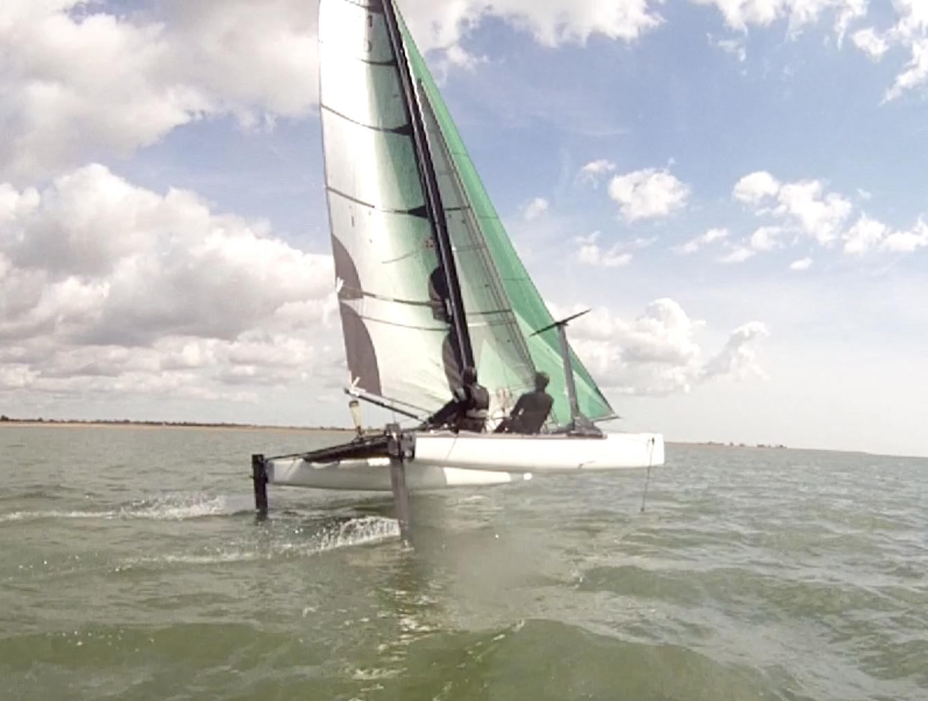

This is the first catamaran to be fitted with canted T foils. The 20 degree outwards cant is designed to give least drag, imitating the windward heel of a moth sailing upwind.

The windward foil can be hoisted out of the water without disconnecting the control wand mounted on the bow – a gull wing system that may well be another first. The gull wings have other advantages:

* There is no need to insert the foils from the bottom of the boat, allowing it to be easily assembled and launched from a beach.
* Light wind performance is enhanced by withdrawing the foils completely and using conventional daggerboards.

The Vampire, originally an M20 from Marstrom Composites in Sweden, is 20 foot long and 12 foot wide sporting a 27sqm rig, and a further 27sqm spinnaker. Over the last four years it has taken line honours in the major UK and North European long distance races such as Round Texel, Raid de Houat, Kent Forts Race and the Three Piers Race.

|  |  |
| --- | --- |
| Macintosh HD:Users:william:Desktop:Screen Shot 2014-08-26 at 12.21.11.png | Macintosh HD:Users:william:Desktop:Screen Shot 2014-09-02 at 12.19.50.png |
| The Vampire foiling in light winds | Vampire foil configuration with windward board raised |

**The development team**

**William Sunnucks** has been seeking a way to combine moth and catamaran technology since learning to sail a Moth in 2009. Further inspired by the 2013 C Class championship in Falmouth, he drew up the canted T foil concept to be built on the Vampire as the test bed.

The concept was developed by fluid dynamicist **Kevin Ellway**, designer of the Exocet International Moth, the first to be designed completely using mathematical models. Scores of virtual moth designs were “flown” before putting the final design into production, and the same general approach has been taken with the Vampire project. He is now working on rig developments to get the best out of the platform.

The foils have been built in Brightlingsea Essex by **Graham Eeles** a specialist boat builder engaged in a number of innovative projects. He has converted the desktop theory into strong and practical foils and has been coaching for the early test outings.

Enquiries to William Sunnucks, East Gores Farm, Coggeshall CO6 1RZ or [William@sunnucks.co.uk](mailto:William@sunnucks.co.uk) or 07771940763. At present the photos and video footage are rudimentary, but better ones will be available in due course. Further decisions on the sailing programme will be made over the coming weeks.

**Notes on foiling configurations – for information**

The International Moth class started foiling at speed about 10 years ago. It has now established itself as the fastest sailing dinghy with a Portsmouth number of 590, nearly 15% faster than an F18 catamaran. They use T foils with a wand to control the ride height.

|  |  |
| --- | --- |
| Macintosh HD:Users:william:Desktop:Screen Shot 2014-09-03 at 12.52.00.png | Macintosh HD:Users:william:Desktop:Screen Shot 2014-09-02 at 12.19.16.png |

T foils were first applied to a catamaran by the “Off Yer Rocker” C Class team in 2007. The foils were vertical and both remained in the water. The boat flew, but was never thought to be fast. More recently the Whisper project supported by Southampton University has been following this line of devleopment.

|  |  |
| --- | --- |
| Macintosh HD:Users:william:Desktop:Screen Shot 2014-09-01 at 09.29.54.png | Macintosh HD:Users:william:Desktop:Screen Shot 2014-09-02 at 12.19.39.png |

The 2013 America’s cup saw 72 foot catamarans foiling at 40 knots downwind. This L Foil technology was also applied in the C Class Championship, “the LittleCup”, at Falmouth in September 2013. Commercial production has started using the same principles on the Flying Phantom and Nacra FCS.

|  |  |
| --- | --- |
| Macintosh HD:Users:william:Desktop:Screen Shot 2014-09-01 at 10.02.59.png | Macintosh HD:Users:william:Desktop:Screen Shot 2014-09-02 at 12.19.25.png |