

**Minutes of a meeting of the Sailing Committee held on Monday 20 February 2023 at 7pm (hybrid format)**

**Attendance**

|  |  |  |
| --- | --- | --- |
| Role | Name | Attendance |
| Rear Commodore Sailing | Steve Gray | Yes |
| Sailing and Membership Secretary | Sally Gostelow | Yes |
| Commodore | Andrew Jackson | Yes |
| Training Principle | Jo Wyles | Yes |
| Chief Instructor and Sailing Equipment Supervisor | Ruth Oliver | Yes |
| Race Recorder Coordinator | Fiona Clarke | No |
| Support Boat Team Representative | Sam Turner | Apologies |
| Laser Class Captain | Mike Oliver/Adam Whitehouse | Yes |
| Tasar Class Captain | Rick Perkins | Via Zoom |
| Merlin Rocket Class Captain | Jon Bloice | Apologies |
| General/Slow Handicap Class Captain | David Connor | Apologies |
| Small Catamaran Class Captain | Glenn Cook | Yes |
| Big Catamaran/ Asymmetric Class Captain | Peter King | Yes |
| Cruisers Class Captain | Jeremy Scott | Yes |
| Cadet Captain (represented by) | Matt Crockatt | Via Zoom |
| Windsurfing Fleet Representative | Simon Reynolds | Yes |
| Cadet Chair | Ian Massingham | Via Zoom |

**Actions & decisions**

Minutes of the January meeting approved.

Mike Oliver introduced his replacement, Adam Whitehouse . Mike was thanked for all his input over his 7 years in the role.

**Masts in Rigden Shed**

Remaining masts to be moved from shed to beach and labelled. Action: Peter King

Laser top masts to be stored under boat covers on owners dinghies. To be communicated to fleet by Adam Whitehouse. Action: Adam

**Race Officer Training**

Race Officer training scheduled for 12 March. Steve asked class captains to promote the training to their classes. Action: class captains.

**New Sailing Members**

Sally presented new members list.

**Equipment Status**

Jo and Ruth advised all will be ready for the new season. See attached slide for details.

**Ramp**

A vote of thanks was raised to Mike Oliver and Harry Whelan for cleaning the ramp in time for the new sailing season.

**2023 Programme**

Sailing schedule published online. Printed programme to be sent to members w/b 21 February. PDF version due to be posted on website by Robert Govier. Thanks to Fef Griffin/Wendy Fitzpatrick for compiling the Programme and to Glenn Cook for a speedy turnaround of printing.

Whitstable Week to be added to the agenda. Action: Steve Gray

Sam Turner reported by email that the new duty roster is live and duties are being filled fast.

**Dart 18/B14 Open (30 Sept-1 Oct) – Update**

Glenn in early stages of planning event. Decision on whether to include Shearwaters delayed until clearer idea of how many Darts/B14s attending. A meal and band will be required.

T**raining and Cadets**

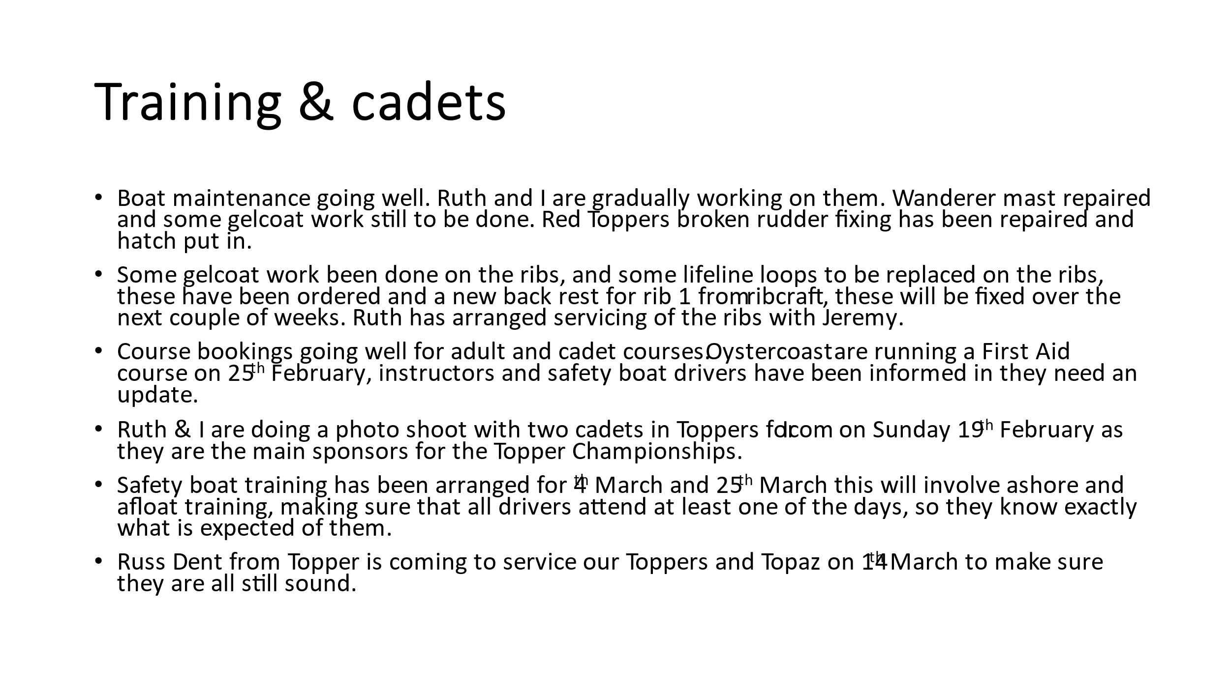

**Other matters**

**Tractor** – Jo Wyles liaising with David Figgis regarding the arrival of launch/recovery tractor by 4 March. Action: Jo Wyles

**Windsurf Racks in Upper Rigden Shed**

Simon Reynolds confirmed that he has completed alterations to board racks. He asked for the SC to look into possible re-design and overview of storage within the upper shed. It was agreed an analysis of storage in the shed should be carried out following the working party. Action: Simon Reynolds/Sally

**Holidaycottages.co.uk – Sponsorship**

Sponsorship confirmed for 2023 - slide deck circulated with agenda.

**Racing Tips Evenings**

Rules and protests already taken place – tactics organised for Wednesday 22 February. A vote of thanks raised for Jonathan Bentman for organising the events.

**Evening presentation**

Andy Jackson reported that WYC had received an enquiry from Adam Taylor (a keen canoeist) offering to present a talk on “Islands of the Medway Estuary” to members. This was something the SC thought members would be interested in. Andy to liaise with Maureen Bush to find a suitable date. Action: Andy Jackson

**Cruiser Class**

Jeremy Scott addressed the meeting with his plans to promote the Cruiser class within the club. He is undertaking to:

* Review the number of active cruiser members.
* Reinstate WYC’s mooring buoy in the Swale;
* Encourage cruiser members to join in with Wanderer cruises;
* Look into training opportunities (VHF/navigation etc) with WYC training and OysterCoast watersports;
* Review the possibility of a swinging mooring off the club for members and to encourage visiting yachts;
* Introduce demo trips – possibly to be included on “Discover Sailing” day;

Steve had received a request from the 420 class Association for WYC to host a regatta in 2024. To be declined. Action: Steve Gray.

**Working Party**

Mike Oliver will distribute a list of jobs to class captains. Class captains to as their fleets to attend the working party. Action: class captains.

Date of next meeting – 24 April – 7pm (hybrid format).

Steve Gray

February 2023