

**Minutes of the General Committee held on Monday 8TH January 2024 7pm**

**at WYC.**

**Present:** Andrew Jackson (Chair) AJ, Steve Gray SG, Mike Oliver MO, Maureen Bush MB, David Figgis DF, Jo Wyles JW, Dickie Ledger DL, Fef Griffin FG.

**Via Zoom:** Terry Davis TD.

**1 Apologies for absence** – Philippa Bloice, Robert Govier, Amy Moore

**2 Minutes of previous meeting Monday 13th November 2023** - Approved unanimously.

**3 Correspondence -** none

**4 Matters arising from previous meeting:**

(a) Maximum numbers allowed for an event

The New Year’s Eve party was used to review the maximum capacity of the club for an indoor event. 120 tickets were sold with a further 10-15 band/staff members. Security reported 105 ticket holders attended the event, though not all at the same time. It was agreed to review capacity event by event but that 120-150 is potentially viable.

(b) Organisation of social events

MB proposed that social members are asked to volunteer to help organise social events.

**Action MB**

**5 Accounts 2022-2023 and budgets 2023-24 MB:**

The draft 2022-2023 accounts were presented and accepted unanimously. It was noted that a modest surplus was recorded but a substantial amount of the loan was still outstanding.

Proposed quarterly budgets were also presented and accepted by the meeting.

The meeting agreed a vote of thanks to Chris Jarrett for his assistance.

It was agreed that MB and SG will discuss 2023-2024 forecourt rental with Keith.

**Action MB/SG**

Prioritising of capital expenditure will follow a review of the premises by TD later in January.

**Action MB/TD/MO**

**6 WOFC update: TD**

Discussions are ongoing with Matthewat CCC ref requirements, in particular with reference to the recently published draft Whitstable Harbour Strategic Plan.

**7 Office report: MB**

The membership report was reviewed and it was noted that total members at end Dec 2023 are the same as end Dec 2022.

MB advised that a further reminder will be sent to advise that bar cards will be frozen for those not renewing by end Jan and the rejoining fee will be charged. It was agreed that timings for advice of late payment penalties should be reviewed for next year. **Action MB**

**8 Sailing Report SG**

**Winter series**: 4/7 races completed – AiH 11 active boats, average start 4.0, Lasers 15 active boats, average start 6.4.

**2023 summary published.**

**2024 programme:**

Ready to publish (meeting agreed to publish) - Transition to racing, organised cruises and Kayak/SUP dates included. **Action RG**

Possible additional Solo open Sept/Oct.

**Holidaycottages.co.uk** – sponsorship for 2024 under discussion

**Strategic plan status** (updates highlighted in yellow)

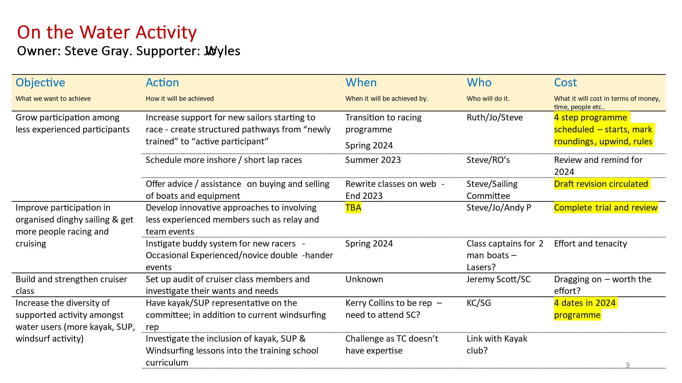

**9 House report: MO**

Completed:

1. Window sash replaced in top office no 2 (Keiths) Jayme

2. Tea bar steps repaired. Jayme

3. Pump replaced on heating system

4. 2 x new tub chairs re-upholstered from Sturts.

To complete:

1. Quote obtained for kitchen deep clean and install extract duct access panel. LCS Facilities. £830+ VAT.

2. No 1. External balustrade replacement next two weeks. Quotation also being obtained for replacement external rear kitchen door and frame. Jayme.

3. Cellar floor further discussion with Tony Hennessy (social member).

4. Property walkaround with Terry Davis ref Rigdens Roof. Veranda canopy, Stroud Shed options.

5. Video drone survey of main club building roofs to be carried out when weather conditions are suitable, to establish extent of roof works required. No 1, 2 and 3-4 Sea wall. Sam Turner

6. Minor electrical items.

7. Ramp clean prior to start of season – volunteers required!

**10 Bar report DL:**

Dicky reported the bar is running well.

**11 Training report: JW:**

The demo Argo borrowed from Topper in November was ideal for training, three of us went out and found it to be very stable and plenty of room, easy to handle and so have done a deal with Topper and bought it; we have also ordered a further Argo to arrive in March. This will mean we have two larger boats for training which will easily take 3 adults or 4 cadets.

The training programme has been finalised for 2024 and will go live on the bookwhen system on 15th January at 6pm. Cadet parents have been told about the date, as Cadetfest gets booked quickly.

Ruth is booked onto the RYA Conference in Oxford on 27/28th January which should be good for new ideas and to see what other clubs are doing.

RYA On Board is holding a training session at WYC on 18th January for other local clubs to come along to as well as our instructors.

We have 8 new assistant instructors for this season who will start their training in March with Ruth and I, hopefully leading on to becoming DI’s the following year.

We have 6 current AI’s that are looking to do the DI course this year and 4 DI’s looking to do their Senior Instructors course. It’s good to see that we’re still getting plenty of home-grown instructors.

**Strategic plan status:**

Building relationship with Oystercoast:

They ran a VHF course in November at the club over several evenings for club members.

Safety boat course planned for 9/10th March and discounted for WYC members.

First Aid courses: dates still being discussed for coming year.

Transition to Racing:

The planned transition to racing sessions will help cadets and adults who are keen to start getting into racing.

**AOB:**

FG to arrange a new members meet and greet session. **Action FG**

FG proposed a lunch event to recognise and thank safety and committee boat drivers and recorders which was agreed. **Action FG**

**Date for AGM Sunday 24th March 2024 after sailing.**

The meeting closed at 7.50pm

Date of next meeting Monday 12th February 2024