

**Minutes of the General Committee held on Monday 12TH February 2024 7pm at WYC.**

**Present:** Andrew Jackson (Chair) AJ, Steve Gray SG, Mike Oliver MO, Maureen Bush MB, David Figgis DF, Jo Wyles JW, Dickie Ledger DL.

**Via Zoom:** Terry Davis TD.

**1 Apologies for absence** – Fef Griffin; Phillipa Bloice; Robert Govier; Amy Moore

**2 Minutes of previous meeting Monday 7thth January 2024** - Approved unanimously.

**3 Correspondence -** none

**4 Matters arising from previous meeting:**

(a) Organisation of social events:

MB reported that no social members had volunteered to help organise social events, but Phillipa Bloice has agreed to help organise the end of year ball.

(b) Meeting with Keith ref 2023-2024 forecourt rental took place and a revised schedule of payments agreed.

(c) Prioritising of capital expenditure:

MB advised that the cellar floor will be upgraded shortly, DL pointed out that will mean that draft beers will not be available for about two weeks while the new floor cures.

The premises were reviewed by TD and a report circulated – as a result priorities are a new deck awning, repair to the clubhouse roof and making minimum necessary upgrades to the Stroud Shed. Provision will be made for legal costs for the beach as required.

**5 WOFC update: TD**

Discussions ongoing with further meeting on Feb 20th.

**Action MB/TD**

**6 Office report: MB**

The membership report was reviewed and arrangements for the AGM on March 24th agreed.

MB to email members with list of open GC positions to encourage volunteers to join the GC.

**Action MB**

**7 Sailing Report SG**

**2024 programme:**

Published to website - Transition to racing, organised cruises and Kayak/SUP dates included.

Handbook in print (now delivered), Solo open not happening, work has commenced on Topper training/open.

**Holidaycottages.co.uk:** sponsorship for 2024 agreed – launch before Easter.

**Strategic plan status:** (updates highlighted in yellow)

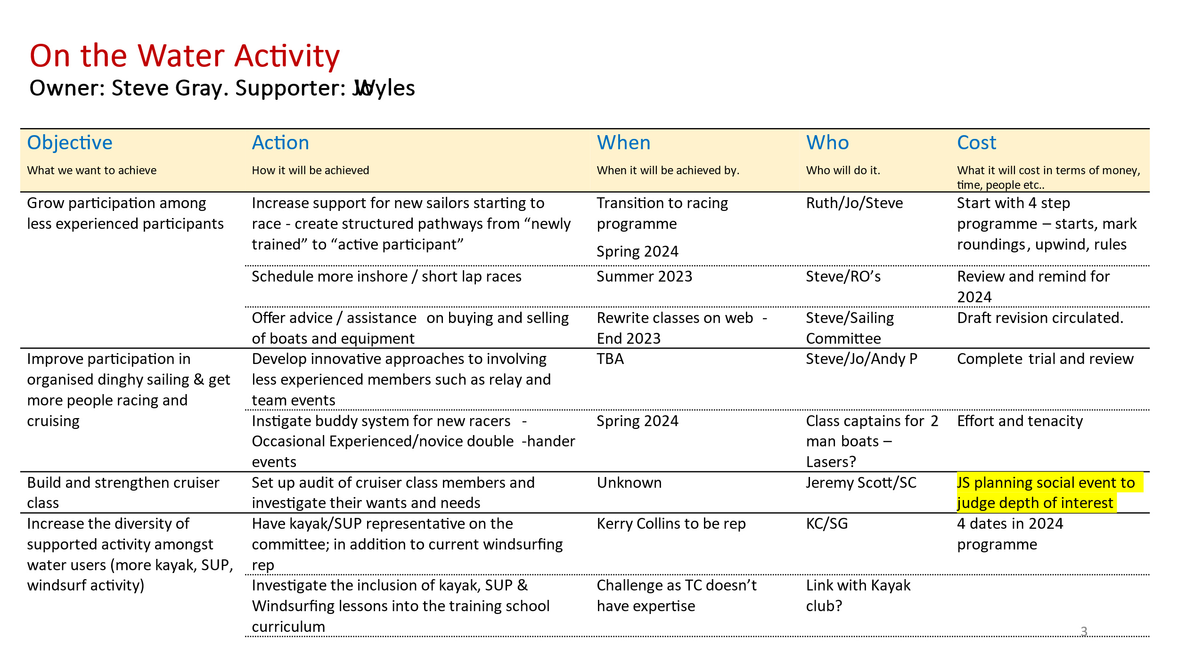

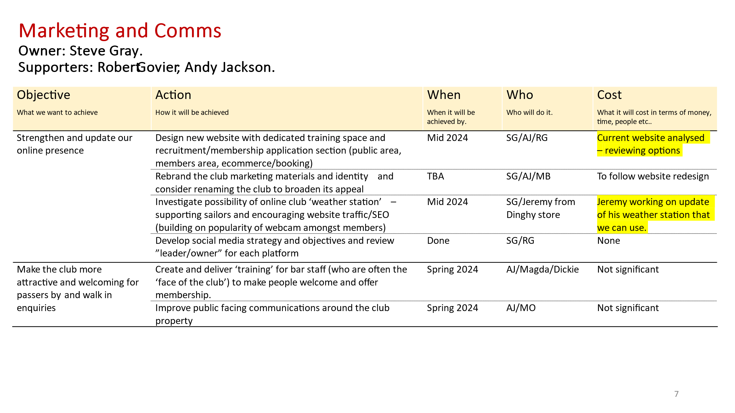

**8 House report: MO**

Completed in last month.

1. kitchen deep clean and install extract duct access panel.

2. No 1. External balustrade replacement

2. Further repairs to veranda support timbers and planks. Jayme

3. Electrical. External emergency lights fitted to Ladies and Gents external doors. Sundry other electrical works.

4. Video drone survey of main club building roofs carried out and photos and video sent to Wood Roofing for quotation.

To complete.

1. Quotation obtained for replacement external rear kitchen door and frame and work ordered. No 1. Jayme.

2. Cellar floor works agreed with Tony Hennessy (social member). Liasing with Bar manager.

3. Ramp clean prior to start of season – volunteers required!

**9 Bar report DL:**

Dicky reported the bar is running well.

**10 Training report: JW:**

Bookings going well for courses - Cadetfest fully booked with a wait list.

RYA On Board programme ran a training session at WYC on 7th Feb, useful evening for ideas about membership, such as new memberships to include courses or boat hire fees.

First Aid course arranged for 2nd March with Oystercoast and RYA safety boat course 9th / 10th March in conjunction with Oystercoast, 5 members booked on so far.

Dinghy Instructors course also planned for 1st – 5th July with RYA holding it at Whitstable YC. Hopefully also a holding a Senior Instructors course in September.

Maintenance on ribs and other training sail boats nearly complete.

**AOB:**

The meeting closed at 7.50pm

Date of next meeting Monday 11th March 2024