

**Minutes of the General Committee held on Monday 11th March 2024 7pm**

**at WYC.**

**Present:** Andrew Jackson (Chair) AJ, Steve Gray SG, Mike Oliver MO, Robert Govier RG,

Maureen Bush MB, Jo Wyles JW, Dickie Ledger DL, Fef Griffin FG. Guest Amy Moore AM.

**Via Zoom:** Terry Davis TD, David Figgis DF.

**1 Apologies for absence** – None

**2 Minutes of previous meeting Monday 12th February 2024** - Approved unanimously.

**3 Correspondence –** Whitstable Carnival Committee have asked if we would be interested in organising a float. JW to ask cadets if they would like to take this on. **Action JW**

Simon Reynold has asked to see the club’s Development Plan. AJ replied and the plan will be posted on the website (see item 4b).

**4 Matters arising from previous meeting:**

1. MB emailed members with a list of open GC positions to encourage volunteers to join the GC, no one replied.
2. It was discussed how best to share the Development Plan with members. It was agreed it would be emailed out to all members including a link to the club’s website where it could also be viewed. SG to update Development Plan with addition of publication date ready for circulation. **Action SG**

**5 Arrangements for AGM**

The following will be voted on by the members at the upcoming meeting:

1. Proposed Resolutions for Rules update to be passed by 30 voting members or 15% of the members eligible to vote whichever is the lesser.

Resolution 1: It is proposed that the changes advised are accepted in a positive manner.

Resolution 2: It is proposed that the General Committee have the authority to change the WYC Rules Section 7 – Trustees - in line with the legal advice once it is received.

1. Election: The following groups require election by two thirds of the members eligible to vote:
2. Flag Officers re standing: Rear Commodore -Steve Gray. Rear Commodore House - Mike Oliver.
3. General Committee members re standing:

Maureen Bush – Office.

Terry Davis – Property.

Robert Govier – IT.

Jennifer Griffin – Meet and Greet.

Richard Ledger – Bar.

Jo Wyles – Training Principal.

1. Commodore – David Figgis standing.
2. New general Committee members standing: Andrew Provan- Social events.

Amy Moore – Social events. Jane Davidson – Social events.

**6 WOFC update: TD**

Terry reported ongoing negotiations and discussed proposed meetings with WOFC.

**7 Office report: MB**

In addition to the office report: -

Filming another Whitstable Pearl, bringing in money for the club.

MB is in discussions with the HMRC regarding our VAT.

The GC voted unanimously to repay £15,000 off the loan.

Simon Reynolds spearheading plans for the Stroud Shed, the first objective is to make it waterproof.

The Beryl Cook talk was well received. Next talk is Medway Muddies.

**New Members report**: 2 social families, 2 water user families and one cadet joined.

**8 Sailing Report: SG**

RO training and first race March 24th.

Handbook circulated; work has commenced on Topper training/open.

Holidaycottages.co.uk: launch before Easter.

Strategic plan status**:** (updates highlighted in yellow)

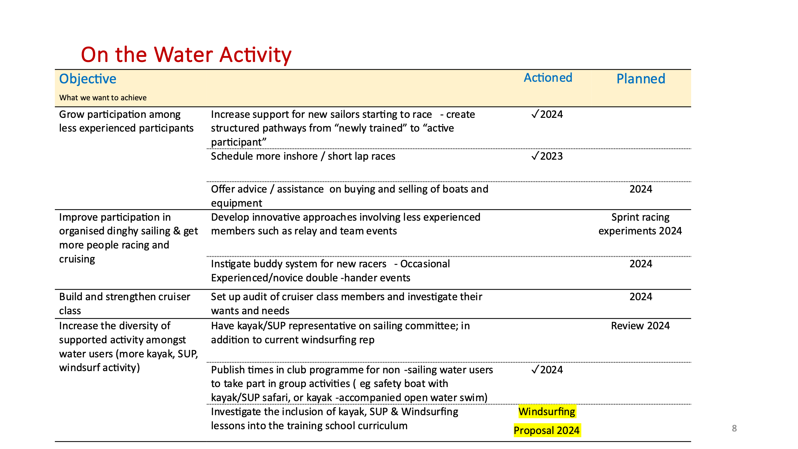

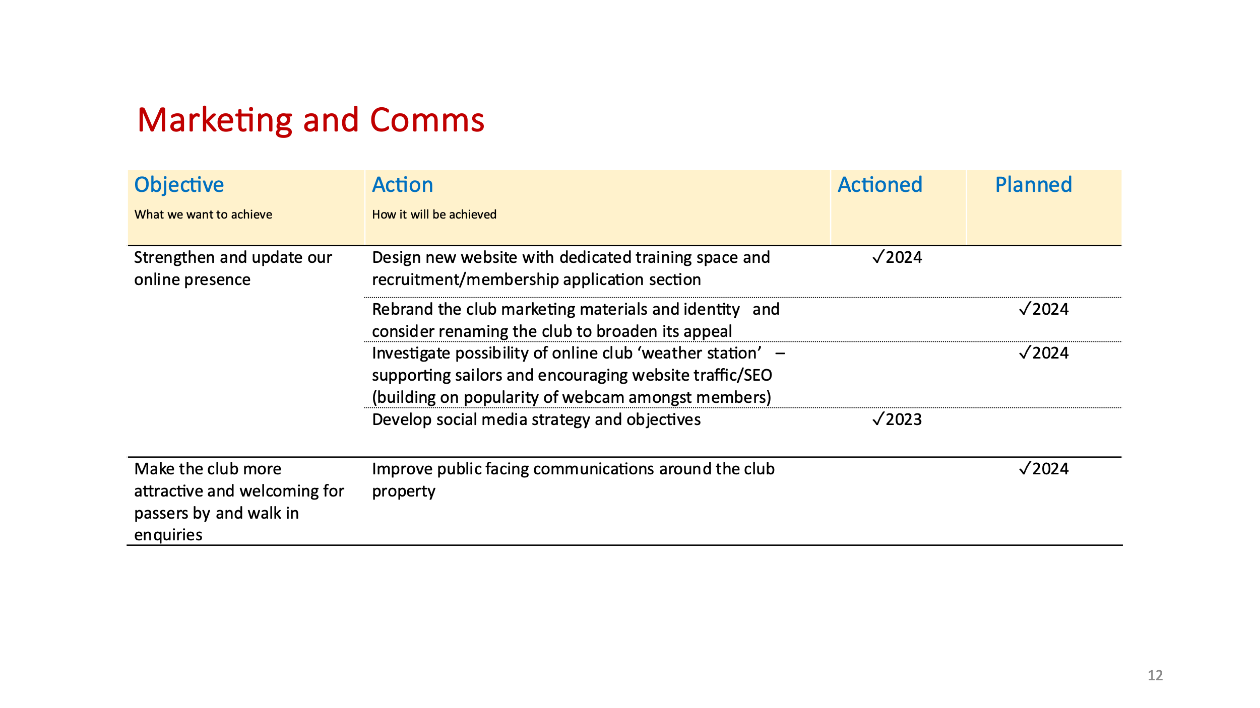

**9 House report: MO**

**Completed works in last month.**

1. Cellar floor replacement part complete. Tony Hennessy (social member).

2. Ramp cleaned. Thanks to Harry Whelan and James Puckett.

3. Veranda canopy cross members repaired. Currently researching replacement – possibly using an aluminium framed marque.

4. Main club building roofs repairs ordered with Wood Roofing – scaffolding will be erected on front pavement.

5. Rigdens rear escape door repaired.

6.  All annual compliance and testing items have been completed.

**To complete.**

1. Order placed for replacement external rear kitchen door and frame No 1. Jayme.

2. Quotes being obtained for redecoration of high level elevation to front of clubhouse. To be carried out when scaffold erected for roof repairs. Also, quotation to redecorate handrails to sea room flat roof.

3. Working Party arranged for 23rd March. Skip ordered to clear rubbish from the “Pit”. Various jobs are being organised to “Spring Clean” the club and surroundings.

4. Engineer called out to repair bar air conditioning unit.

**10 Bar report DL:**

Dicky reported the cellar floor is nearly finished. Draft beer back on next week.

**11 Training report: JW:**

Maintenance on ribs and other training sail boats now complete. All kits have been washed and checked for the season.

Beginning of March, we had 6x club members completed their RYA First Aid course, which was run by Oystercoast. Another course being run on 14th April.

Oystercoast are also running an RYA safety boat course 9th/10th March and again 6x club members are taking part, 3x of the Dinghy instructors are doing the course, as they hope to do the Senior Instructors course later this year and it is a requirement to have it.

Club Safety Boat training is on 16th March, this is for anyone who already has a PB2 and wants to drive the ribs for safety boat cover during racing. This is going over the clubs policies and procedures and getting out on the water to lay marks etc. People can still book on to this.

The other new Topper Argo arrives on 20th March, ready for the start of the cadets / courses staring at Easter.

We have had a lot of cadets wanting to become Assistant Instructors this year, 12 in total. Ruth and Jo start running the session on 17th March, we have two groups this year, they do 3x weekend sessions off the water, learning about the various procedures, land drills, presentations, powerboats, first aid then a morning on the water landing and launching, rigging and sailing. This will then give us more people to help with courses and cadets and lead them on to becoming dinghy instructors in the future.

The meeting closed at 7.45pm

**Date of next meeting Monday 8th April 2024**