

Minutes of a meeting of the Sailing Committee on Monday 19 January 2025 at 7pm (hybrid format)

Attendance
Role | Name | Attendance
Rear Commodore Sailing | Steve Gray | Yes
Sailing and Membership Secretary | Sally Gostelow | Yes
Commodore | David Figgis | No
Training Principal | Jo Wyles | Yes
Chief Instructor | Katie Berrington | Yes
Race Recorder Coordinator | Fiona Clarke | No
Support Boat Team Representative | Matt Young | Yes
Laser Class Captain | Paul Kelly (PK) | Yes
Tasar Class Captain | Ali Nicolson | No
Merlin Rocket Class Captain | Jon Bloice | Apols
General Handicap Fleet Captain | Vacant
Small Catamaran Fleet Captain | Glenn Cook | Via Teams
Big Catamaran/ Asymmetric Fleet Captain | Peter King | Yes
Cruisers Fleet Captain | Jeremy Scott | No
Cadet Fleet Captain | Niall Martin | Via Teams
Windsurfing Fleet Representative | Simon Reynolds | No
Beachmaster | Georgios Rafeletos | Yes

Actions & decisions Minutes of the November meeting: approved.

Holiday Cottages have confirmed sponsorship of £5k for 2026 training and club events.

Committee personnel – a number of changes to note:
General Handicap fleet captain - position vacant
Tasar fleet captain - Ali Nicolson stepping down
Cadet fleet captain - Niall Martin
Race recorder coordinator - Rachelle Hockey taken over from Fee Clarke

Due to Maureen Bush stepping back from the club managerial role and Sally’s imminent retirement, both roles have been amalgamated. Anthony Middleton the new Club Manager is due to start on 1st February.

A vote of thanks was raised to Ali and Fee and the committee welcomed Niall and Rachelle.

A proposal was put forward to have one fleet captain to represent Merlins, Tasars and General Handicap. Steve to discuss with Jon Bloice. Action: Steve
Equipment Status
The committee boat has been craned out and a maintenance list established. Peter volunteered to check on the mooring once there is a suitably low tide. Action: Peter King

New Sailing Members:

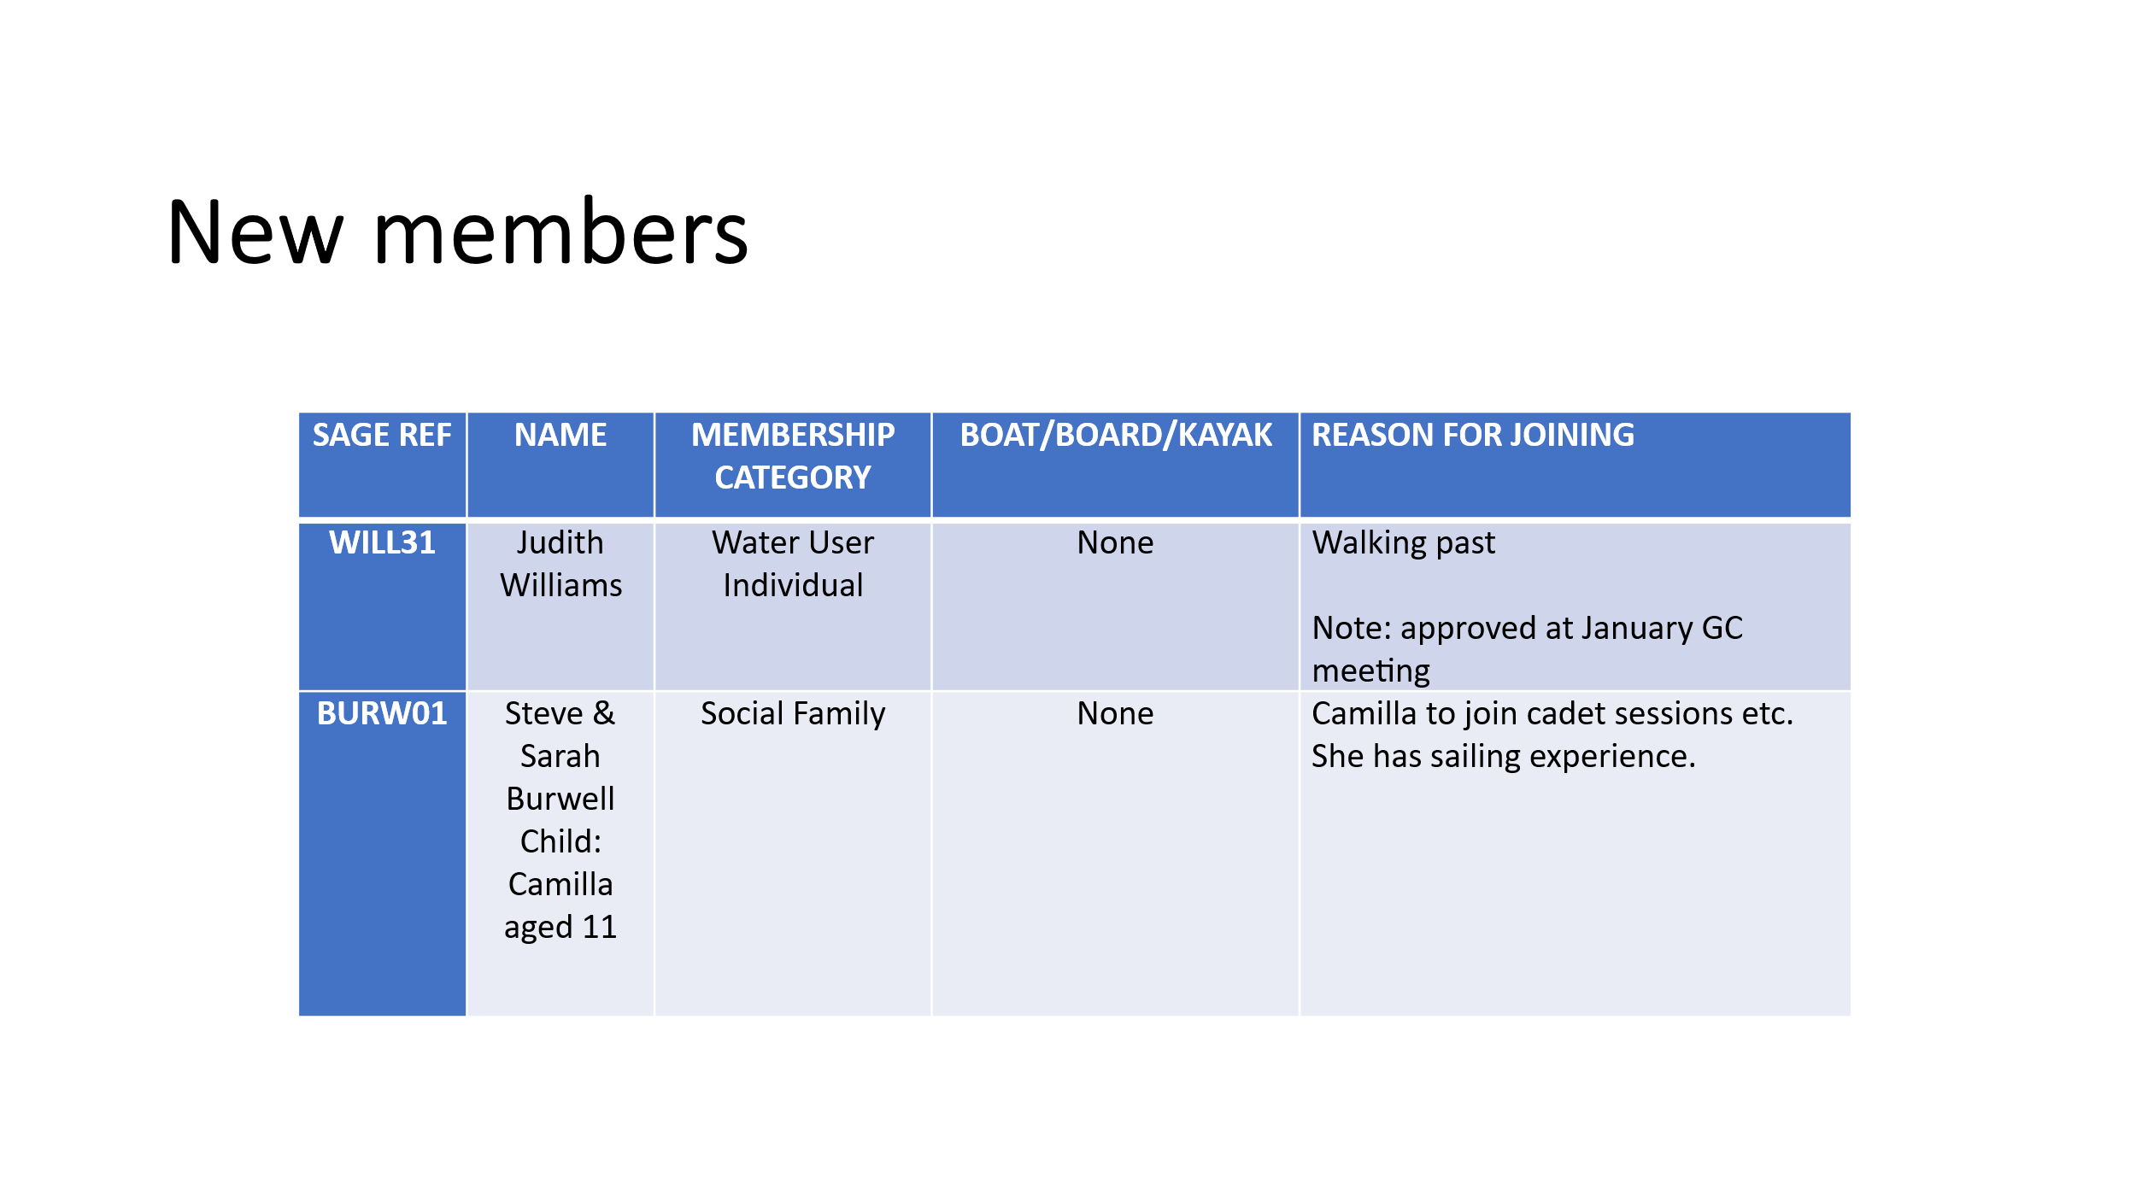

2025 Programme

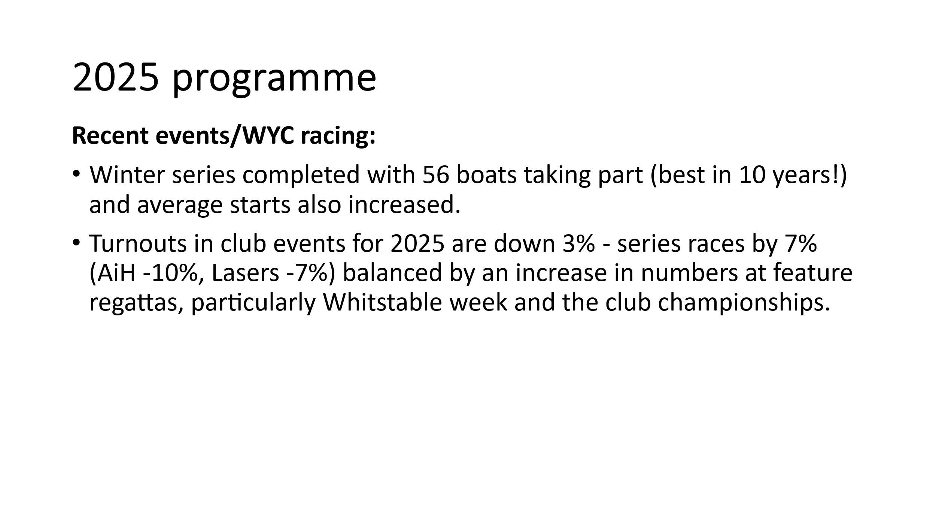
2026 Programme
Topper SE traveller & training (April 18/19) Organisers: Niall & Steve. Niall confirmed he is liaising with ITCA and all arrangements are in hand. A total of 5 RIBs required - Island Barn SC loaning one for the event. Katie sourcing a further instructor. Steve and Niall to discuss budget. Action: Niall/Katie/Steve

Town regatta (May 2-4). Organiser: Steve.

Merlin Rocket silver tiller/ Tasar open meeting (May 30/31). Organisers: Jon & Steve. RO Tom Bruton. Steve to meet with Tom and Jon to discuss. Action Steve/Jon

Discover Sailing (June 14). Organiser: Club Manager & Training School.

Laserfest (Jun 27/28). Organisers: PK, Steve Gray & Tom Bruton RO. PK will advertise on social media that entries are now open. In order to encourage WYC’s younger members to take part, PK agreed to ask amongst his fleet if anyone is willing to lend a Laser for the duration of the event. Training school have two to loan. Action: PK

Whitstable week (July 29-Aug 2). Organiser: Steve.

Wanderers (with club racing) (Aug 15/16). Organisers: Richard Maltby & Steve. A maximum entry of 20 agreed.

Club Championships (Aug 29-31). Organiser: Steve. RO: Mark Fagg

Dart 18 open & B14s (Sep 26/27). Organisers: Glenn & Steve. RO: Tom Bruton. Simon Hadley to be approached to help with the event . Steve to supply Glenn with his contact details. Action: Steve/Glenn

125 year anniversary – 2027
Steve attended meeting to discuss 20/01 and will update next SC Action: Steve

Training & Cadets
- All courses currently being put onto website for end of January opening for bookings. Steve to assist with advertising on social media. Action: Katie
- Pages on website being updated.
- All clothing to be washed and check this month.

Class comments
Peter advised that all scrap metal (excluding masts) is due to go in early February.

David Figgis has again very kindly volunteered the use of his tractor for the 2026 season. The rubber matting on the beach to be in place in time for the first race of the season.

PK reported on an excellent Laser Christmas party.

Other matters
Steve reported on the shortage of committee and safety boat drivers, currently there are not enough to cover the duties this season. The training school have a number of Power Boat Level 2 courses scheduled for 2026. Katie volunteered to ask participants at the end of each course if they are willing to join the drivers team and, if so, forward their details to Matt Young. Further training will be available to members willing to become a committee boat or safety boat driver.

Niall had been approached by a number of non-members who are keen to join in with winter sailing. It was noted that WYC rules allow visitors for a 14 day period if agreed by a GC member. Matt confirmed that only one safety boat can be deployed for the winter sailing which limits the number of dinghies to 12. It was agreed that Niall could invite a couple of visitors this season and it would be reviewed for 2026/7. Action: Niall

NSSA event (July 20-26). It was agreed that WYC will loan a RIB.

A request has been received to host RS500 Europeans in 2027. To be declined.
Action: Steve

ITCA have requested a training event in January 2027. Niall will contact the ITCA to enquire further before a decision is made – the committee noted that January is a poor month for weather. Action: Niall

IOCA (Optimists) have requested an end of season championships at WYC in October 2027. Up to 180 boats expected. To be discussed further before responding. Action: Steve

Date of next meeting: Monday 16 February 2026

Steve Gray
21 January 2026

