

Minutes of a meeting of the Sailing Committee on Monday 21 September 2026 at 7pm

Attendance
Role | Name | Attendance
Rear Commodore Sailing | Steve Gray | Yes
Club Manager | Anthony Middleton | Yes
Commodore | David Figgis | No
Training Principal | Jo Wyles | Yes
Chief Instructor | Katie Berrington | Yes
Race Recorder Coordinator | Rachelle Hockney | No
Support Boat Team Representative | Matt Young | Yes
Laser Class Captain | Paul Kelly (PK) | Apols
Tasar Class Captain | Liz North | Teams
Merlin Rocket Class Captain | Jon Bloice | Apols
General Handicap Fleet Captain | Vacant
Small Catamaran Fleet Captain | Glenn Cook | Apols
Big Catamaran/ Asymmetric Fleet Captain | Peter King | Yes
Cruisers Fleet Captain | Jeremy Scott | No
Cadet Fleet Captain | Niall Martin | Yes
Windsurfing Fleet Representative | Simon Reynolds | Yes
Beachmaster | Georgios Rafeletos | Apols

Actions & decisions
August’s minutes approved.
Dinghy cruising: New rules have been adopted by participants including mandatory use of VHF radio.
Cruiser Fleet mooring buoy proposal: Further enquiries ongoing.

Equipment Status
Yellow rib will be replaced. Cormorant will be sold. A new rib to be sourced in short term with longer term plan for graduated renewal of safety boat fleet to be agreed. SG to present programme at next GC meeting. Action SG
PKi to work on Blue and Pink rib hulls over winter with Peter Griffin to be used for Frostbite series.
Review issue of buoys drifting during races to ascertain if equipment or training issue.

New Members

SAGE REF | NAME | MEMBERSHIP CATEGORY | BOAT/BOARD/KAYAK | REASON FOR JOINING
GREE13 | Natasha Green  +  Henry James, | Social Individual
COX07 | Andrew Cox | Social Individual
SMIT22 | Neil &  Jackie Smith | Water User Family
HUTS01 | Rachel Hutson, partner Claude Sapp  +  Roderick & Daphne, both 16 | Social Family
BART07 | Tom & Holly Barton,  Lily, 4  Polly, 3 | Water Family
CHAR02 | Dan Charlish, Laurie Nicoll  +  Ari, 3 | Water User Family | Leader (?) dinghy owner
SAFF01 | Hugh & Rhianna Saffrey  + Margaux, 2 | Water Family |  | Own Wooden Cruiser…. (communicated about this - not on site) Has booked course
HAWK05 | Leslie Hawkins | Social Individual
NUGE01 | Daniel & Dannielle Nugent  +  Atticus 3  Rafferty 1 | Water User Family |  | Friends
BEAD01 | Tina Beadle | Social Indiv | WLSC to Sept 27
MOLL01 | Aoife Molloy and Danny Mitry.  +  Isabella, 14  Aoibhinn, 12  Saoirse,10 | Social Family
CAPE01 | Tracey Capelett | Social Indiv | WLSC to Sept 27
GUST01 | Annie Gustafson | Social Indiv | WLSC to Sept 27
OSLE01 | Karen Osler | Social Indiv | WLSC to Sept 27
EARE01 | Margaret Earles | Social Indiv | WLSC to Sept 27
ALDR02 | Tim Aldridge  Sarah Ginter  +  Shane 11 | Social Family |  | Shane doing course
OMAL01 | Fiona O'Malley &  Cary Anning  +  Layla 11  Raphael 14  Noah 9  Harper 4 | Social Family
WARD01 | Claire Ward  & Seamus Gallagher  +  Jayne 15 | Water User Family
TRUD01 | Arlie Trudgill | Water User Indiv
TRUD02 | Faye Trudgill | Water User Young Person

2026 Programme

- Summer series (early) – Saturday AiH: Jon Dennis, Laser: Max Hunt; Sunday AiH: Steve & Mei Baker, Laser Nick Stephens
- Summer series (late) – Saturday AiH: Phil Emery/Julie Nuttall, Laser: Peter Gowring; Sunday AiH: Mark Barnes/Joe Barton, Laser: Paul Kelly
- Wednesday series – Rick & Sarah Perkins
- All above series saw improved average start numbers…
- Wanderer nationals/Wayfarer Southerns – Aug 15/16. 10 Wanderer’s and 5 Wayfarers took part – Wanderers won by Richard Maltby. SG will report to sailing committee regarding the incident that required the RNLI to intervene.
- Club championships – Aug 29-31. A windy weekend with Saturday blown off. Great job by race team, safety boat team, bar team and Jeremy Scott – congratulations to Mark Barnes and Joe Barton our 2026 club champions!
- Dart 18/B14 open – Sept 26-27
- KSSA Training – Oct 10
- Meeting of Sailors – Oct 11 – Ideas sought for discussion points.
- Prizegiving – Nov 1, 4pm – moved from original Nov 8 date

Training & Cadets
- Been a busy summer of courses, but all went well. Two adult courses still to run a level 2 this weekend 12th/13th September and a Level 1 26th/27th September.
- We hope to run a cadet course at Westbere during the October half term. We have 5 more cadet sessions for the season, they have been well attended this year and even when windy, we have been able to get them out with instructors to make sure they have a good session. A number of cadets now also enjoying racing at the club.
- Two more powerboat courses still to run, the end of September and mid October, still one space on each available to book.
- Improvers has been going well, with 3 sessions left, but several are hiring boats to use for free sailing or racing.
- KSSA training day on 10th October, up to 40 boats coming, entry opens on 19th September. We are usually a popular venue as they like to get in some sea sailing.

NM discussed ideas for young sailors moving from cadets to racing, with initiatives for Topper and Laser race training. Course proposed for Autumn half term.
Meeting agreed to review ideas to promote cadet and transition sailors in main racing series at next meeting. Action All

2027 Programme
- Topper training & traveller open May 22/23
- Tasar Europeans/Merlin silver tiller Jun 4–6
- LaserFest July 3/4
- 125 Anniversary Regatta Aug 18–22
- Also have requests from Wanderer and Dart 18’s not yet agreed.
Meeting agreed that Wanderers be asked to include their 2027 open/cruising event within the 125 regatta. Action SG/RM

125th Anniversary

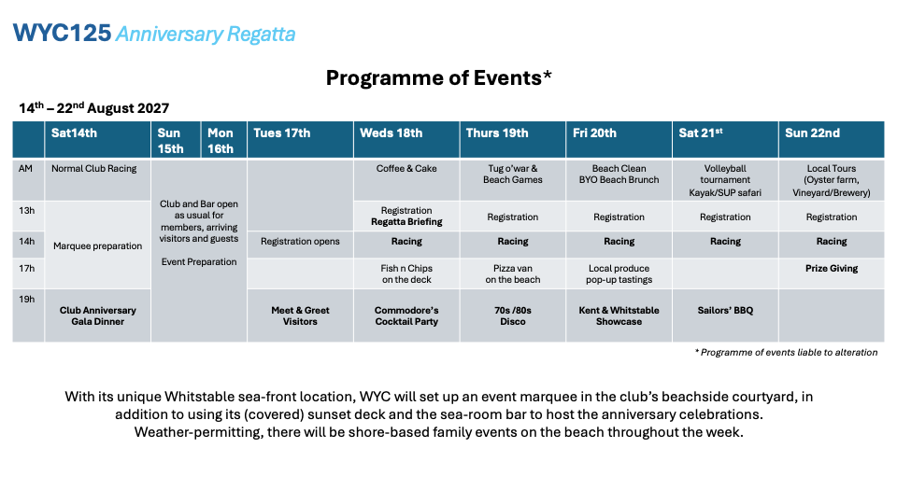

NM proposed greater youth participation, including a three day regatta.
SR asking UK windsurfing association to attend 125.
Meeting to suggest ways to increase appeal of the sailing side of 125 – respond at next meeting. Action All

Class comments

Liz North: Three club participants in recent Tasar European Championships. Mark Barnes & Joe Barton (2nd out of 22 participants), Zanna Gooch & Liz North (10th) and Ali Nicolson & Jo Phillips (15th). Committee congratulates all.
SR: Has regular requests for windsurf training, but club has no instructor. Sorting through equipment which club members can use.

Other matters
Noted but not discussed: Zanna Gooch leading initiative to encourage more women into sailing, in early stages and currently called Female Futures.

Next Meeting – 19th October 2026

Steve Gray 25 August 2026

